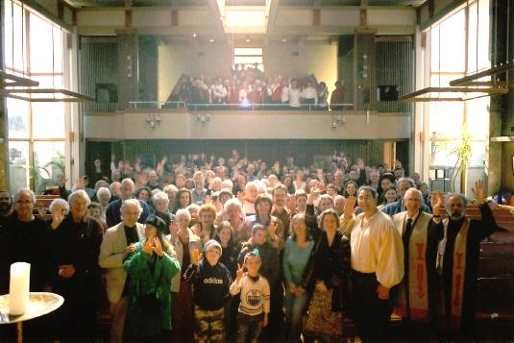

What We Wish People Knew About Unitarian Universalism

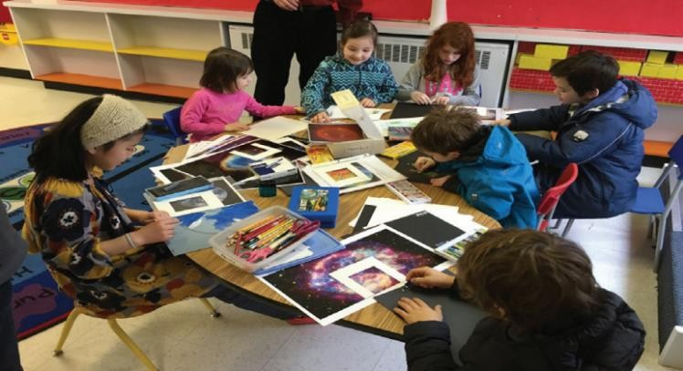

Introduction
Well, the trouble begins with the name, doesn’t it? Unitarianism.  Unitarian Universalism. And that’s only the beginning. When was the last time someone found out you were a Unitarian, and asked: “So, what’s that? What do Unitarians believe?” Ever happen to you at a Thanksgiving dinner? The question comes up, a hush settles over the turkey, and all eyes swivel your way. I remember once saying that we’re “a post-Christian, pluralistic religious community.” Killed the conversation then and there.  It’s difficult to describe or define feelings and things that are important in our lives: think of love or honour, happiness, grief, and loyalty. Or religion. When asked to define “poetry,” the great English writer Samuel Johnson replied: "Why, Sir, it’s much easier to say what it’s not. We all know what light is; but it’s not easy to tell what it is."  So, rather than trying to tell or define what we believe, in the following pages Canadian Unitarian Universalist ministers want to share with you some thoughts about what we wish others knew about our religion. After all, we believe its history, its message, and our way of being in community can bring real spiritual depth, right relationships, meaning and positive support for children and families, and more justice and love into our lives and our world. Otherwise, why go through the trouble of showing up? –  Rev. Steven Epperson |  | 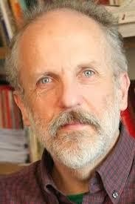  Rev. Steven Epperson, Unitarian Church of  Vancouver

I believe that there is a light in this faith. A light of possibility. And fanning its flames might just be what can offer healing for what ails us. Rev. Julie Stoneberg

FIRST: We’re an unusual, pluralistic faith community
 |  | I wish people knew how unbelievably revolutionary and entirely soul-satisfying
 |  | Unitarian Universalism is. – Rev. Jane Bramadat
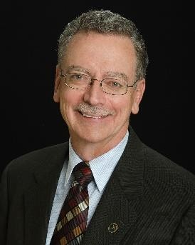 |  | I wish everyone knew that Unitarian Universalism is a faith tradition that is totally unlike any other. We do not define ourselves by a limiting set of beliefs. We affirm that people of good will, regardless of individual spiritual and religious orientation, can have their lives enriched, as we work to heal the world and learn from each other—building relationships across cultural, social, economic and religious  boundaries. – Rev. Norm Horofker
Rev. Norm Horofker, Unitarian Universalist Church of Halifax |  | I wish that everyone knew that UUs have rich conversations about all manner of
 |  | things religious, theological, ethical and that we know how to listen deeply and stay
 |  | curious even when we don’t understand or when we disagree. – Rev. Debra Thorne
 |  | We do not judge people by their theologies and beliefs, but by the way they live
 |  | those theologies and beliefs. – Rev. Brian Kiely
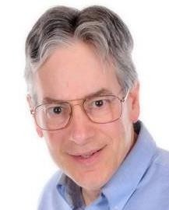 |  | What makes us unusual, if not unique, is what I see as the main question all Unitarian Universalists must deal with which is, not what we believe (we all have the freedom to work that out for ourselves), but how the beliefs we hold inspire us to lead our lives differently than if those beliefs were not held and valued.  – Rev. Arthur Berman
Rev. Arthur Berman |  | This is one of the first things that attracted me to this religion; it has sustained me as
 |  | a Unitarian Universalist over the years. I discovered, from my first encounter in
 |  | Utah of all places(!), that a Unitarian Universalist congregation makes generous
 |  | room for god-believers and atheists, for pagans, Buddhist-oriented meditators and
 |  | wandering, non-ritualistic agnostics alike. Over the years, I have met with you at the
 |  | doors of death and presided at your memorial services. Each time, whether you’ve
 |  | believed in a life after death, or not, whether you were pagan or atheist, or whatever,
 |  | you have affirmed for me the power of this religion as something unique and
 |  | precious. – Rev. Steven Epperson

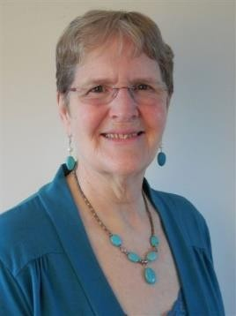Our is a faith built on principle, on values, not creed. Our Seven Principles are guidelines for living. They don't offer answers, but rather suggest things you might consider as you are forming or reviewing your life and belief decisions.
Rev. Frances Deverell

Rev. Brian Kiely

We are a living tradition and that means we are constantly growing and evolving. We are just learning how to hold compassion in our hearts for not only those who are different from ourselves, but also for those who are like us. – Rev. Samaya Oakley

I wish people knew how strongly we believe that revelation has not been sealed. We continue to evolve, gain insights and wisdom based on what we learn and experience. As individuals and as a faith, we are continually in process. What a source of hope there is in this view of life and of ourselves! – Rev. Julie Stoneberg

I think my favourite principle is the free and responsible search for truth and meaning. I like that we are called to question what we think we know, and then how we stay open to further truths as they may reveal themselves. We are encouraged to check the sources of our beliefs and we honour many potential sources. We are called
to look at the contradictions and deepen our thinking when we find them. This heritage comes to us from our enlightenment commitment to the scientific method for gaining knowledge and our multifaith exploration which has engaged us as we try to understand how humanity can have unique cultures and yet be one in unity, all equal and all with inherent worth and dignity. – Rev. Frances Deverell

I wish the word “religion” was not so un-cool and dangerous to people that they fear checking us out. And at the same time, I wish that those who are looking for spiritual depth wouldn’t dismiss us because they may think we are too loosey-goosey, or that “we can believe anything” and still be Unitarian. We do have boundaries!

Rev. Wendy McNiven

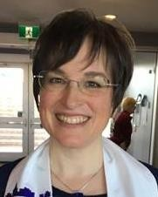  Rev. Beckett Coppola, Kingston Unitarian Fellowship |  | I wish people knew that Unitarian Universalism is not what they think of when they  think ‘religion’. Especially in British Columbia, I find a negative knee-jerk reaction to anything religious/spiritual and feel that what is being reacted to is not the faith tradition that I am a part of. I would want people to know that we have a rich and deep history full of flawed and inspiring women and men. – Rev. Shana Lynngood  I think the biggest thing that people don’t know, or perhaps don’t understand, is what it means to be a pluralist faith system. Being pluralist doesn’t mean you can think  whatever you want, and it doesn’t mean that you can do whatever you want. Pluralism means that the faith formation of one person in a faith community can differ as much as necessary from another’s faith formation, so long as we stay in good relationship with the morals, ethics, and underlying theology of that community and its tradition.  There are religions and worldviews that allow great latitude to their members; in ours, this is broader and larger than in most, and it’s due to our principled pluralism—we all gather and come together in community under a single roof regardless of our theism or non-theism, our relationship with the universe, or our personal understanding of the unseen realms of human existence and experience. There is an understanding that human experience is deeply and uniquely individual for each and every one of us and, as a result, so are our beliefs. – Rev. Beckett Coppola

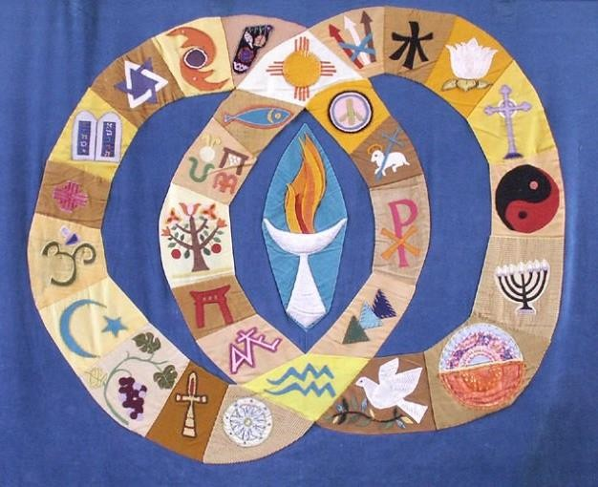

SECOND: We have deep historical roots going back nearly 500 years

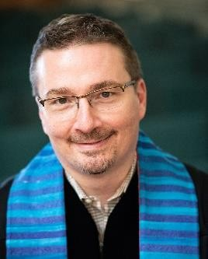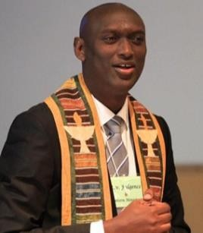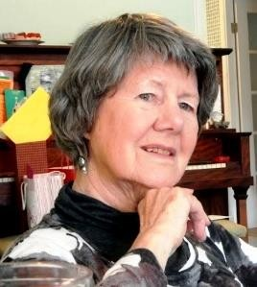What I keep coming back to is a single point: I wish others (and our own people) understood that Unitarian Universalism stands as securely in the lineage of Christianity (and Judaism) as any other branch that has emerged from the Christian story--even though many of us (myself included) consider our tradition largely post-Christian. We didn't arrive on the scene 60 years ago, ex nihilo. We have a storied past that finds continuity with our present. So much of what undergirds our Principles is grounded in the mandate of love and justice found in Jewish and Christian scripture. We distort ourselves unnecessarily when we ignore our roots, or worse, pretend they don't exist.

Rev. Shawn Newton, First Unitarian Congregation of
Toronto

Rev. Fulgence Ndagijimana, Burundian Unitarian Universalist Church / Saskatoon Unitarians

Rev. Anne Treadwell, Grand River Unitarian
Congregation
My wish is that we would take up the mantle to be a shining example of the best that these parent traditions have to offer. – Rev. Shawn Newton

I would stress that we sometimes let others define us. Our tradition originally comes from liberal Christianity and we give the Council of Nicea power it could not claim if we stopped denying our Christian heritage for which we also have martyrs in our history. Rev. Arthur Berman

I wish people knew that Unitarian Universalism is actually an organized religion. Some people, including some well-meaning religious professionals, think that we are a bunch of reactionary humanists and atheists and wounded Christians who meet and complain about the state of the world. Although we may do some of that, I know by observation and experience that we are a people building a beloved community with a valid worldview, deep aspirations and longings expressed through meaningful rituals. -

Rev. Fulgence Ndagijimana

We've been around for a long time. Our ideas about the oneness and lovingness of the divine can be found from the early history of Christianity onwards and are present in many other world religions. As an organized movement, we began in Reformation times and have an evolving relationship with Christianity and other traditions. Ours is no fly-by-night faith; certainly, it’s not static—it’s always open to enrichment by new ideas and new people—including you, perhaps! – Rev. Anne Treadwell

We arose five hundred years ago out of rational radical reform and embody liberal, progressive leanings that arise out of all cultures when conditions are supportive.

– Rev. Fran Dearman

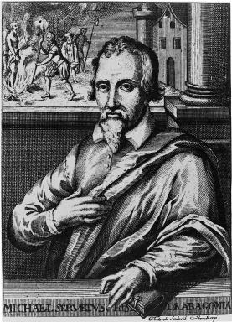
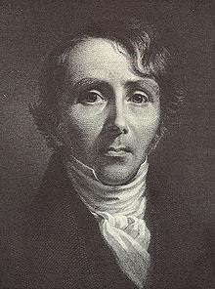
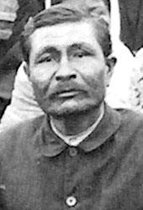
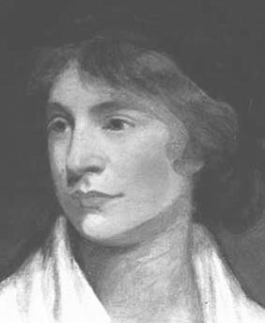
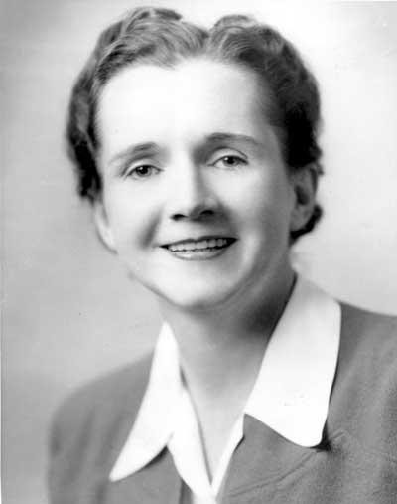
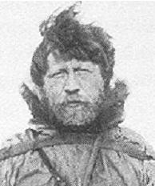
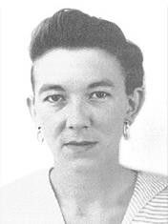
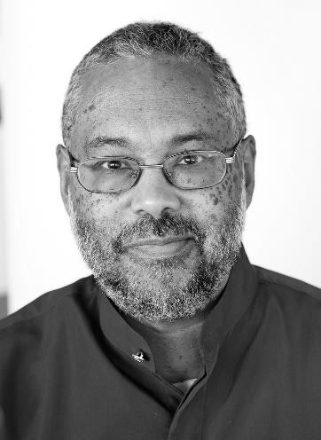

Some Unitarian Universalist historical figures:

Top Row: Michael Servetus, William Ellery Channing, Hajom Kissor Singh
Middle Row: Margaret Fuller, Mary Wollstonecraft, Rachel Carson
Bottom Row: Vilhjamar Stefansson, Margaret Laurence, Mark Morrison-Reed

THIRD: When we find our way here, we’ll experience living in
a religious community inspired by shared ideals

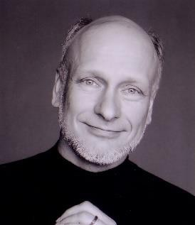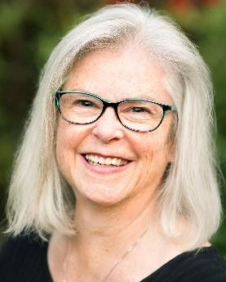We come together to share our humanity. Here, we often share how we raise our children; we share how we handle our greed and our need. We come hoping to share how difficult it is to live a human life, with our unexpected joys and our terrible sadness. We are surprised by the similarity of our lives and encouraged by compassion, both given and taken. When we share our human lives with vulnerability and kindness we learn how to better live them. People often say they come for community but I believe they mean this. – Rev. Wayne Walder

Rev. Wayne Walder, Neighbourhood
Unitarian Universalist
Congregation

Rev. Debra Thorne, Beacon Unitarian
Church

I wish everyone knew firsthand the power of a community that puts respect of every person first. If you haven’t been respected in your life, the experience is utterly
transformative. If you have known respect, then it is vital that you bring it to every relationship, especially to those who challenge your perceptions and ruffle your comfort. I wish everyone knew how shatteringly foundational is the Unitarian first principle: ‘the inherent worth and dignity of every person.’

I wish that everyone knew that our diversity is our strength. If the people of the world are ever going to live in mutual respect of our diversity, then some people, somewhere need to be practicing how to do this. Unitarian Universalists are working on this in every congregation, every week. We are learning how to listen with respect. We are
learning how to love with understanding. We are learning to draw the circle of ‘us’ wider and wider. We are practicing how to live in the healthy and necessary tensions of a diverse community. – Rev. Debra Thorne

This commitment to the search for truth and meaning and right relationship with all
that is keeps me alive. It keeps me exploring and searching. It gives me a community and an avenue to pay attention when I run into a conflict and then open myself instead of closing up, blaming myself or the other into locked, fixed positions. A community of character, where we share values in common, is the key to life-long learning and a rich life. It’s helped me make many new friends from different walks of life.

Rev. Frances Deverell

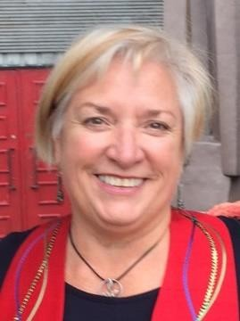  Rev. Julie Stoneberg, Unitarian Fellowship of Peterborough  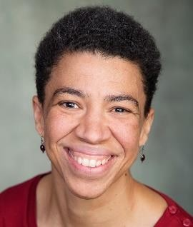  Rev. Shana Lynngood, First Unitarian  Church of Victoria  Rev. Samaya Oakley, South Fraser  Unitarians |  | There is nothing like the experience of being in a religious community (along with a commitment to staying in it!). From isolation to connection and belonging, from being unknown and unseen to being known and seen, from hubris to humility, from  materialism to personal relationships, from 'freedom' to accountability, from inaction to service with and for others—being in religious community is transformative and builds a life full of meaning. I wish that people knew that making a commitment to a community, and showing up to make meaning together, really makes a difference! The thing is, we and our faith are nothing without people participating in it. Without that,  it's just a voice in the wilderness, and not a very loud voice at all.  – Rev. Julie Stoneberg  I would want people to know that we believe in the power of communal exploration of all the deepest questions life throws our way. I would want them to know that we  believe that there is no one, single answer that is right or best to the big questions. I would want them to know that our congregations are containers for exploration that are both challenging and nourishing. I want them to know that in our communities there is always more work to do--more exploration, not easy or simple or given answers.  – Rev. Shana Lynngood  We are learning about liturgical generosity – which simply means that we are learning that each part of our worship services, and what we offer as a whole, may not be serving any one individual at a particular moment, but we show up anyway. We show up because we are learning that our presence may make the difference for someone  else. That song we sing, or that reading that’s offered, or that program being offered may not meet our needs at this moment in time. And realizing that, we still show up, knowing that it will change the life of someone else, that our smile may be the best  thing in someone else’s life and that it will change the course of their day – and that’s worth it! – Rev. Samaya Oakley  There is a huge difference between individuality and individualism. Individuality is valuable, precious, and should not be erased, marginalized, or otherwise oppressed. By contrast, individualism is toxic, destructive, capitalistic, selfish, narcissistic, etc.
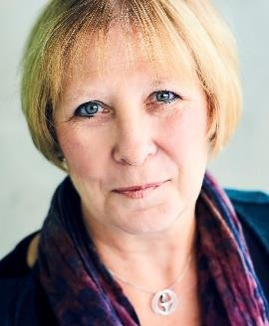

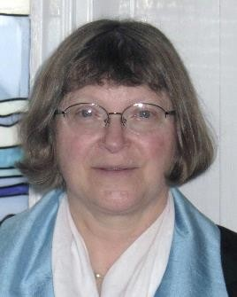Here is where I wish we knew is what it means to be a covenantal faith. A people bound together by a community covenant, by an understood set of agreements around how we will behave and be in relationship with one another, is wonderful. However, we are a people of faith who do this, AND who intentionally do this as one of the groundings of our faith and theology: this isn’t a social club, it’s a congregation; this isn’t just a social justice movement, it’s a religion.

Rev. Beckett Coppola, Kingston Unitarian
Fellowship

Rev. Fran Dearman

The community is the locus, the centre and source, of the horizontal covenant—the covenant between and among a people. The vertical covenant’s locus is individual—it is the foundation of the agreements around a person’s own faith formation and how they interact with the cosmos honouring their individuality and personal experiences.

Horizontal and vertical covenant, the value of individuality without individualism— they achieve their greatest expression and hope in a pluralist covenantal faith and its work in the larger world as a cultural change agent. – Rev. Beckett Coppola

We see a coherence to the world, and a generosity that includes all. So, let us love one another, for love comes from the holy, and if we cannot love one another—and
ourselves—how could we love the whole? Live your faith, light the world (old bus poster from the sixties). – Rev. Fran Dearman

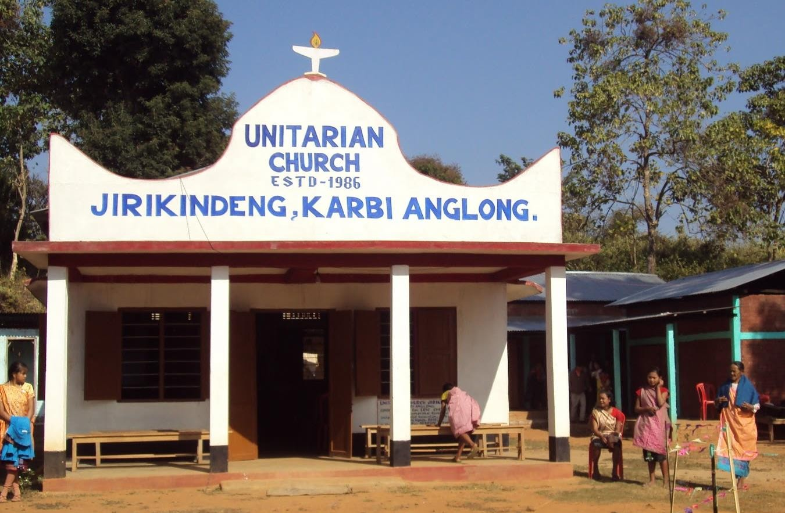

A Unitarian Church in Northeastern India

FOURTH: This is a truly good, inspiring religion for children,
families and adults
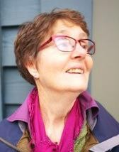  Rev. Wendy McNiven |  | It was my then-teenage sons who helped bring me into this faith. They had high school friends who invited them to their Unitarian Universalist youth group. I was bowled over hearing their reports when they returned home, and especially of how Unitarian adult leaders treated these young people, and my sons—their questions, ideas, hopes and fears, their age-appropriate craziness—with astonishing respect. This helped me pluck up the courage to visit that Unitarian Universalist congregation during a very  turbulent time in my life. And the rest is history… – Rev. Steven Epperson  I wish more people would recognize the life-giving possibilities of Unitarian Universalism, especially for youth whose stage of life is so much about exploring and experimenting with who they are, who they want to be. They’re full of idealism and despair for the world (and sometimes themselves), with no holds barred—just our kind of people—and we value and cherish them so much! I have also seen some of our youth really begin to find themselves in a safe, affirming religious community. It’s not that ours is the only community that can offer this, but I think churches in general (when they’re not narrow-minded), and scorned as they often are, can be really positive influences in young lives. – Rev. Wendy McNiven  I wish people knew Unitarian Universalism is a not a dangerous cult out to destroy families and other traditional structures, but a positive force for good to create brave spaces for truth to be told and spiritual, emotional and human growth to occur.  I wish people knew that Unitarian Universalism has a positive message to share with the world. A message of love, justice for all and an awareness and stewardship for mother earth. – Rev. Fulgence Ndagijimana

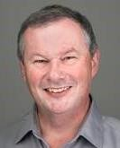So many new Unitarian Universalists have spoken to me over the decades about 'having found a home' in our church. Every time I hear that, I am transported back to my own discovery of this faith. Having grown up in a religion that mostly handed me beliefs, I was deeply relieved and pleased when I found a church where I could think about belief, instead of reciting it by rote. That discovery may not have made me a better person, I'd like to think I would have found my way even in a purely secular world, but I did find that I could live as a more fully integrated person where my personal and religious beliefs matched up. – Rev. Brian Kiely

Rev. Brian Kiely, Unitarian Church of
Edmonton

Rev. Fulgence Ndagijimana, Burundian Unitarian Universalist Church / Saskatoon Unitarians

I wish everyone knew how wonderfully thoughtful, caring and inclusive are the children who are raised in the Unitarian Universalist tradition. – Rev. Debra Thorne

I love it when a UU congregation takes adult programming to gain new insights, learn new cultures, and develop new skills; and then uses their learning to involve the wider community in some way. Examples include shared celebrations across cultures and faith communities.

In Nanaimo, we try to live into our values and our concerns for the homeless by running a shelter that embodies our values and principles. Some congregations took cross-cultural training to learn how to work with refugees and then became advocates for refugees including sponsoring refugees themselves. Many congregations have worked to put their green values into their building. It is examples such as these where I see how Social Action can be both community building and spiritually inspirational.

Rev. Frances Deverell

I wish people knew that UUism is not just for white people. When one enters a UU worship service or a room full of UUs, it is tempting to believe that it is a club of white people mostly nice to each other and having a good time. I wish people knew that despite historical struggles and current realities around race and colour of skin, UUism is engaged in a painful conversation to be open and welcoming to people other than white people, and that people of colour are part of the congregations too.

Rev. Fulgence Ndagijimana

Rev. Samaya Oakley, South Fraser  Unitarians |  | This is a faith that challenges us to grow in to the best versions of our capital S selves in this lifetime. And as each person grows, so do we grow as a faith. We are growing  into what it means to be a Unitarian Universalist when we look at how we have created systems that privilege one class over another, one race over others. It is hard to look at this and not feel fear when the realization hits that all we have been taught and currently know is only one slice of what life is like on this earth. It takes courage and fortitude to look at our place in the interdependent web of life for when we do, with eyes that have been awakened, we see our own part in the one view that takes priority  over others, and the damage, the hurt, the harm it has created. – Rev. Samaya Oakley

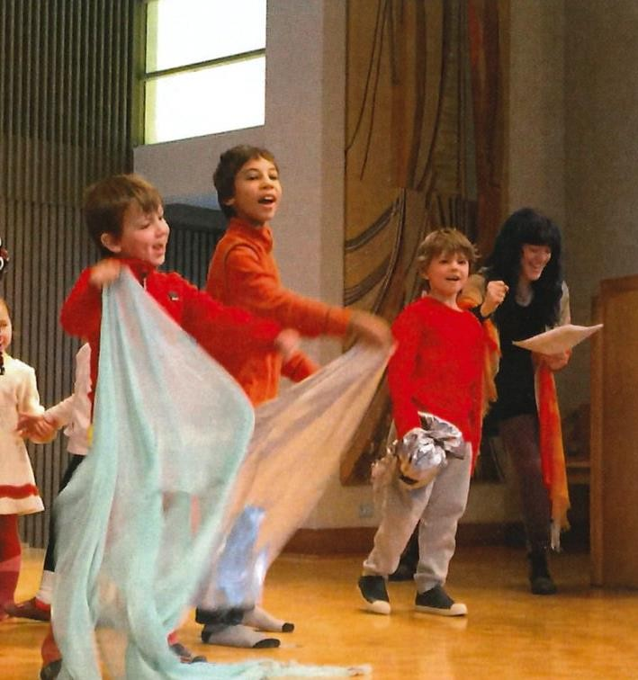

FIFTH: It may be hard to be a Unitarian Universalist, but the fruits of our religion are precious, deeply spiritual and
life-transforming

I wish people knew that it takes work to be a Unitarian Universalist. Some may think that once they walk through our doors, that’s it – they have arrived and found some version of heaven on earth where they can believe what they want. They breathe a sigh of relief, make some connections and carry on as they did before. When in fact, what’s required is time to examine what you believe about creating meaning of life on this earth. It’s a faith that challenges each one of us to answer the difficult questions that arise through living in hard times. What does it mean to be saved as a UU? What does it mean to live in right relationship with the earth? What does it mean when we talk about inclusion and diversity in all of its forms?

Rev. Wayne Walder, Neighbourhood
Unitarian Universalist
Congregation

It may be hard work, but in the end, it brings a tremendous amount of growth, authenticity and integrity to who we are and what we support. It sustains my soul in the darkest of times by providing a community of love and support. It is a tradition I am proud to say that I belong to with my heart, mind and soul. – Rev. Samaya Oakley

Our Unitarian Universalist faith is not easy, yet if we want to live life deeply and suck the marrow out of it, we must try simultaneously to reflect on the life we live while living it. – Rev. Wayne Walder

We ain't perfect, and we freely admit it. Ours is a human institution and so by definition we screw up from time to time. I like to think we are pretty good at admitting our screw-ups and try to address them in a timely fashion with a sense of
justice and with compassion for those who have been hurt along the way. It's not for everyone for lots of very good reasons. Unitarian Universalists get that. If our liberal faith does not work for you, we wish you the very best on your continued search.

Rev. Brian Kiely

Rev. Julie Stoneberg, Unitarian Fellowship of Peterborough |  | I wish people knew about the availability of spiritual experience—whether that be in relationship, or in service, or in listening to our own souls. Within our faith, each person is encouraged in their own way to access these experiences which move us to be open to that which creates and upholds life.  We might really be oases in the desert...not the only ones, of course...but still. Oases. And it feels like society is moving further away from what might save us rather than being drawn toward it. So, what I believe is that there is a light in this faith. A light of possibility. And fanning its flames might just be what can offer a salve for what ails us, what actually may bring healing, or salvation to shattered hearts and our troubled  world.  It really, truly takes all of us to make a whole, and each voice...each doubt...each hand...each ear...each arm...matters. And that you don't get the full experience unless you put yourself into it. – Rev. Julie Stoneberg  We are fragile beings with little control of the world. We cannot predict the future nor change the past, yet we must live within them. We don't know why we were born, nor when we will die. By coming here, we hope to find in each other and within ourselves, the seeds that demonstrate the sacred, that demonstrate hope, that demonstrate goodness. These seed help us fall into love with life again. People often  call this existential search, spirituality. – Rev. Wayne Walder

For more information about Unitarian Universalism, our programs, and a congregation near you, please visit the website of the Canadian Unitarian Council at
http://www.cuc.ca

Compiled and formatted by Marcus Hynes, Office Assistant, Unitarian Church of Vancouver | www.heymarcus.ca

